Assignment

- Explain the main assumptions of Linear Regression in detail.
  - Linearity
    - The relationship between independent variables (predictors) and the dependent variable (outcome) must be linear.
  - Independence of Errors
    - Residuals (errors) must be independent of each other.
  - Homoscedasticity (Constant Variance)
    - Residuals should have constant variance across all levels of predictors.

- What is the difference between R-squared and Adjusted R-squared?
Aspect | R-squared | Adjusted R-squared
Definition | Proportion of variance in the dependent variable explained by independent variables | R-squared that adjust for the number of predictors
Range | 0-1 higher is better | 0-1 , but < R²
As per predictors | Increases or same even if irrelevant | Increase only if new predictors improve model
Interpretation Risk | Can be misleading for multivariable | Provides honest measure of explanatory power

- What are the different types of Regularization techniques in Regression. Explain in detail with cost functions of each technique.
  - Lasso Regression (L1 Regularization)
    - Cost F^{n} :
    - Mode of slope
    - 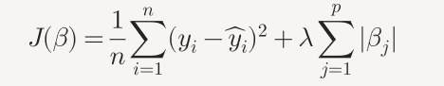
    - pruning a tree: removing branches (features) that don’t add value
    - The penalty shape for L1 is a diamond
    - When the optimization “touches” the diamond’s corners, some coefficients hit zero
    - When to use :
      - many predictors,
      - automatic feature selection
    - L1 (Lasso) will keep only those 3 and set the rest to zero.

  - Ridge Regression (L2 Regularization)
    - Change the Cost F^{n}

    - 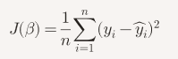
    - 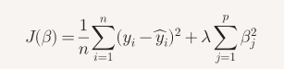
    - It shrinks the coefficient to decrease the error
    - spreading influence more evenly
    - 
    - L2’s penalty is a circle
    - L2 (Ridge) will keep all 10 with smaller weights
  - Elasticity
    - Cost F^{n}
    - 
    - 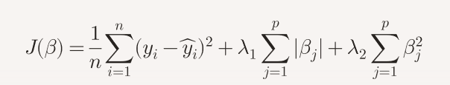
All these regulation will give different result if model is overfitted else no significance change in result

- How logistic regression works for multiclass classification. Explain in detail.

- Explain the performance metrics of logistic regression.

- Use the Mobile price prediction dataset from below Kaggle link and create an end to end project on Jupyter/Colab.

https://www.kaggle.com/datasets/mohannapd/mobile-price-prediction/data

- Download the dataset from above link and load it into your Python environment.
- Perform the EDA and do the visualizations.
- Check the distributions/skewness in the variables and do the transformations if required.
- Check/Treat the outliers and do the feature scaling if required.
- Create a ML model to predict the price of the phone based on the specifications given.
- Check for overfitting and use the Regularization techniques if required
- Compare the performance metrics of training dataset and testing dataset for all the different algorithms used (Linear/Ridge/Lasso/ElasticNet)
  - Answer :
Best alpha by test accuracy:
model alpha accuracy_test rmse_test r2_test
ElasticNet (L1+L2) 0.1 0.787879 157.449595 0.956269
Lasso (L1) 0.1 0.787879 151.981237 0.959254
Ridge (L2) 0.1 0.787879 151.918371 0.959288

Summary of best alpha values:
model alpha accuracy_test rmse_test r2_test
ElasticNet (L1+L2) 0.1 0.787879 157.449595 0.956269
Lasso (L1) 0.1 0.787879 151.981237 0.959254
Ridge (L2) 0.1 0.787879 151.918371 0.959288

